Model Test Paper - I.
Section - A
Section - B
Section - C

SECTION - A

Question 1 to 15 carry 2 marks each.
- 3x + 2y = 6 ;(k + 1 )x + 4y = (2k + 2)
- For what value of k, will the above system of equation have infinite solution.
- Find the median of the prime numbers between 20 - 50.
- Form a quadratic equation whose roots are 3 /2 and -5.
- Prove that : Sec²A / tan A - tan A = Cot A
- Complete the tabel and find CDR.

Age group | Population | Number of Deaths
0 -10 | 35650 | 310
10 - 20 | 37750 | 250
20 - 35 | - | 110
35 - 50 | 30450 | -
above 50 | 20150 | 390
1,40,000 |  | 1200

- Find the GCD of x² - 4x -12 ; x³ + 8
- Find the value of (sin 44 / cos 46) + (sin 46 / cos 44) without using the trignometric
- tables.
- .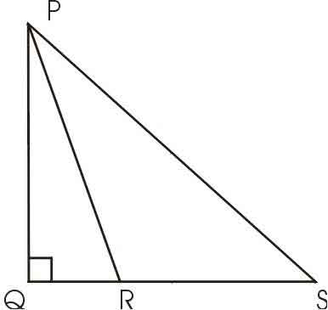
Given : ⎣PQS = ⎣PQR = 90⁰ Show that QS² + PR² = PS² + QR²
- 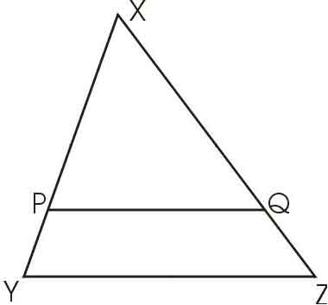
Given : PQ || YZ and XP / PY = 4 / 3. If XQ = 6.6 cm. Find QZ.
- If x³ + y³ / x³ - y³ = 91 / 37 . Show that x : y = 4 :3.
- Aarti buys a saree costing Rs. 2500/- at Rs. 2700/- after paying sales tax.
- Calculate the ratio of sales tax paid by her.
- Find side of square whose diagonal is 12 cm.
- Quadrilateral ABCD is a cyclic quadrilateral in which ⎣ A = 2⎣C.
- Find ⎣A.
- If the mean of the following data is 14.5 Find the value of k.

- Marks obtained (x) 5 10 15 20 25
- Number of student (y) 3 6 4 k 3
- 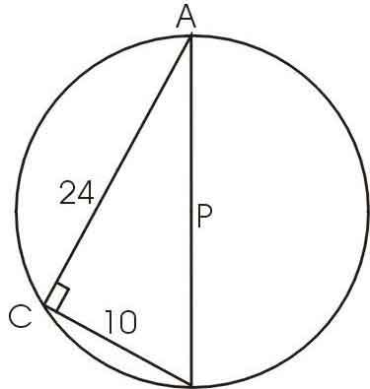
P is the centre of the circle. Seg AB is the diameter, BC = 10, AC = 24. Determine Radius.

SECTION - B

Question number 16 to 25 are of 4 marks each.
- Calculate cost of living index from the following data :-

Commodity | Quantity | Price in 1999 | Price of 2000
P | 5 | 4.20 | 6.00
R | 4 | 5.00 | 8.50
A | 3 | 8.00 | 10.50
G | 7 | 9.00 | 11.50
S | 8 | 12.50 | 16.00
- If Cos²45 + Sin 30 = 2 Cos²A , Find Sec²A.
- Solve graphically 3x - y = 6, 2x + y = 4.
- Show that : - a²(b + c) + b² (c + a) + c² (a + b) +3abc = (a+b+c)(ab + bc + ca).
- 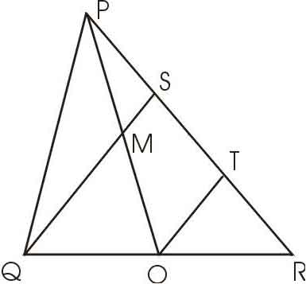
O is the midpoint of seg QR, M is the midpoint of seg OP, seg QS meets side PR at S and QS || OT. Show that PS = 1 / 3 PR.
- The radius of a circle is less than twice the radius of the other by 1 cm.
- The sum of their areas is 34 π sq cm. Find the radius of each circle.
- Draw a circle with O as a centre and radius 4 cm. Take two points A and B on the
- circle such that ⎣AOB = 80⁰. Draw tangents to the circle at the points A and B.
- The radius and height of a solid right circular cylinder are 10 cm and 30 cm respectively.
- It is melted and solid cones are prepared. If the diametre base of the cone is 2 cm and
- its height is 10 cm. Find how many such cones are prepared from the whole metal of the cylinder.
- Find the mean of the following frequency distribution.

Class | Frequency
00 - 10 | 3
10 - 20 | 9
20 - 30 | 15
30 - 40 | 8
40 - 50 | 5

- If a, b are the roots of the equation 4x² - 5x + 4 = 0. Form the equation whose roots are a², b².

SECTION - C

Question 26 - 30 carry 6 marks each.
- Sachin's Annual Income is Rs. 74,600/- (excluding House Rent Allowance).
- His contribution to Provident Fund is Rs. 600 per month and he pays
- Rs. 2,600 as LIC premium during the year.
- Find the tax paid by him during the year.
- a) Standard deduction = 1/3 of total income subject to maximum of Rs. 15,000.
- b) Rate of Income tax for individual income
- i) upto Rs. 35,000 --> No tax
- ii) Rs. 35000 to Rs. 60,000 --> 20% of the amount exceeding 35,000
- iii) Rs. 60,001 to Rs. 1,00,000 --> Rs. 5000 + 30% of the amount exceeding
- Rs. 60,000
- c ) Rebate in tax - 20% of the saving to a maximum of Rs. 12000 whichever is less.
- A vertical tower stands on a horizontal plane and is surmounted by a
- vertical flagstaff the elevation of the bottom of the flagstaff is A and
- that of the top of the flagstaff is B . Prove that the height of the tower
- is h. tanA / tanB - tanA.
- ∑ a ( x - a ) / ( a - b ) ( a - c )= -1. Prove that.
- 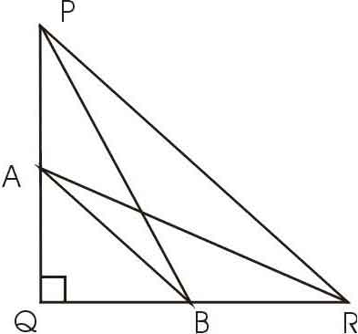
Triangle PQR ⎣Q = 90^{0,} A and B are the midpoints of sides PQ and QR respectively. Prove that 4[ RA² + PB² ] = 5PR²
- In the circle radius 5 cm, AB and AC are two chords such that AB = AC = 6 cm.
- Find the length of the chord BC.

